Instructions for installing Fluid Tester (chrome plugin)

* Open the link https://github.com/ankireddy501/fluidtester/blob/369ed12acccdd6be02d17159ccee80a474b13344/Fluid%20tester.crx
* Click on view the full file

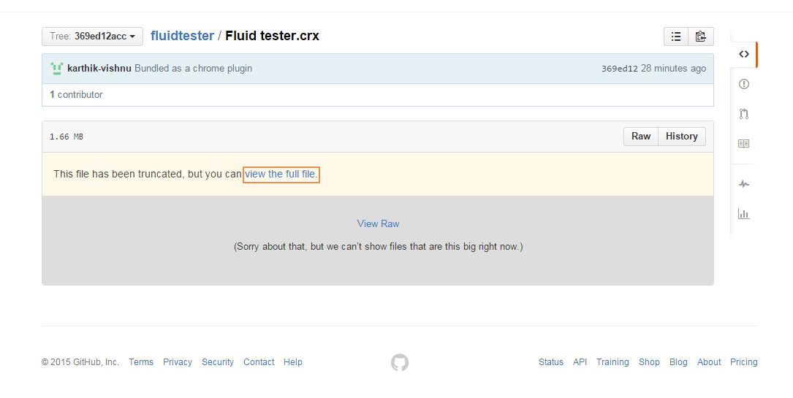

* Fluid Tester file will be downloaded. Extract that file to your desired location
* Open the chrome browser
* Click the Chrome menu on the browser toolbar
* Select More tools -> Extensions
* Enable the Developer mode
* Click Load unpacked extension
* Choose the location where you extracted the Fluid tester.crx and click ok
* After loading the plugin it will look like this

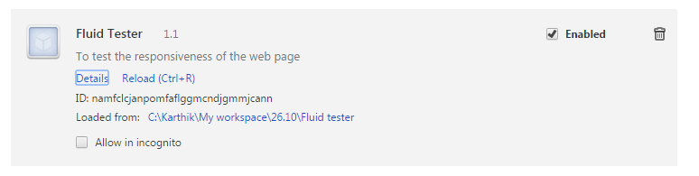

* Make sure that Enabled is clicked
* Click details, a popup window will appear.

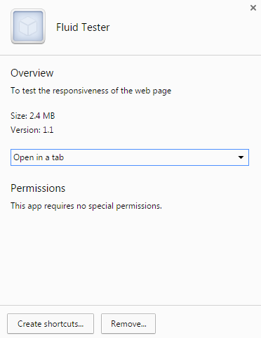

* Click create shortcuts and click create